**1. Identify Bottlenecks in Ticket Resolution by Priority**

**Problem Statement:**  
Analyze the average time taken to resolve tickets across different priorities (P1–P4) and categories to uncover bottlenecks and suggest improvements in SLA adherence.

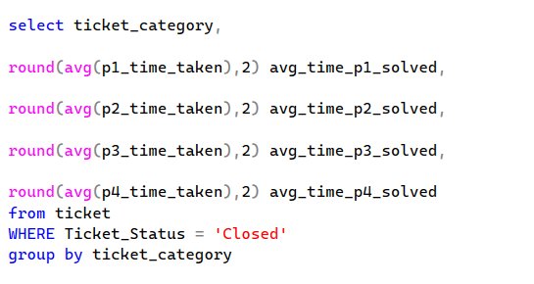

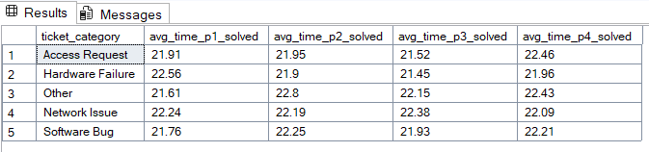

**Business Impact:** Optimize resource allocation and training efforts for faster resolution of high-priority tickets.

**2. Employee Performance Dashboard**

**Problem Statement:**  
Track the number of tickets resolved by each employee, along with the average time taken, to identify top performers and those needing support.

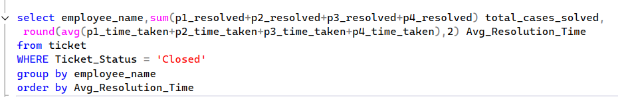

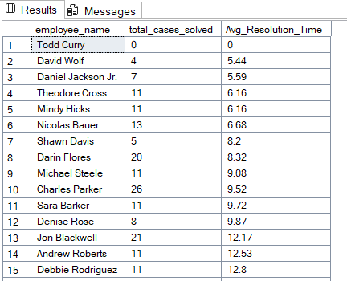

**Business Impact:** Incentivize high performers and provide coaching to underperformers, improving overall productivity.

**3. Trend Analysis of Ticket Volume and Status**

**Problem Statement:**  
Monitor ticket inflow vs. resolution rate over time to detect seasonal trends or periods of backlog.

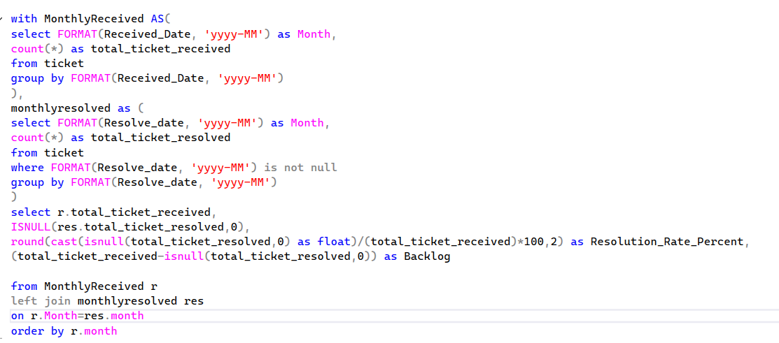

**Business Impact:** Forecast workload, optimize staffing, and avoid service delays during peak times.

**4. Category-Wise Issue Frequency and Resolution Quality**

**Problem Statement:**  
Determine which ticket categories have the highest frequency and slowest resolution times to prioritize process improvements.

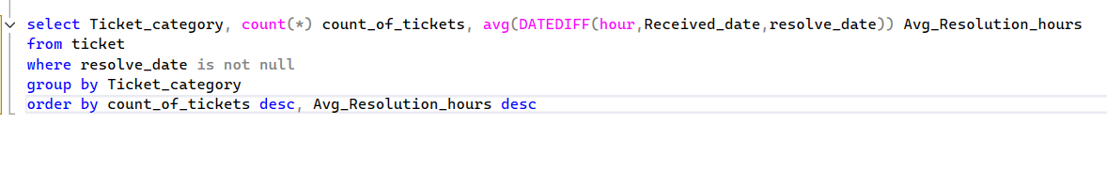

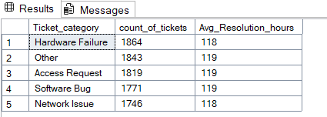

**Business Impact:** Improve root cause analysis and invest in tools/processes that reduce recurring issues.